Tutorial Two

MLP Classifier

Prepared By:
Muhammad Anees
537630

Assigned By:
Dr. Shahbaz Khan

.



NATIONAL UNIVERSITY OF SCIENCE AND TECHNOLOGY
SCHOOL OF MECHANICAL AND MANUFACTURING ENGINEERING

- Task one:
Modify the MLP model to have different numbers of hidden layers and neurons:
Q1: How does increasing the number of layers or neurons affect the accuracy and learning curve?
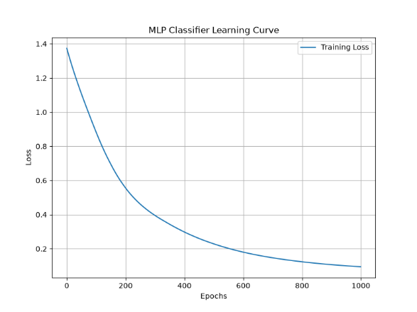
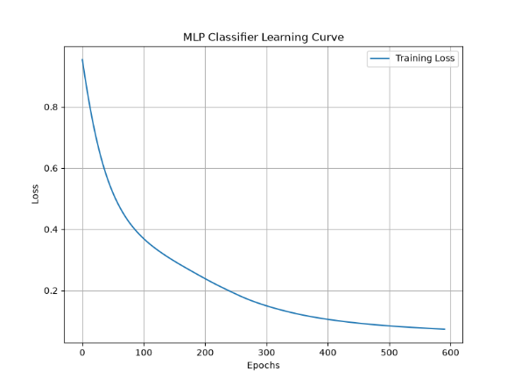
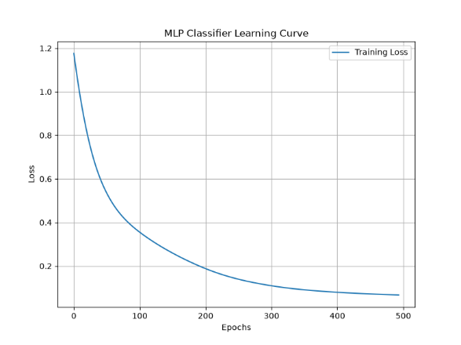
Ans: The following are the results that shows by changing the number of neurons only how the loss is decreasing
1 Layer 100 Neurons
1 Layer 50 Neurons
1 Layer 10 Neurons

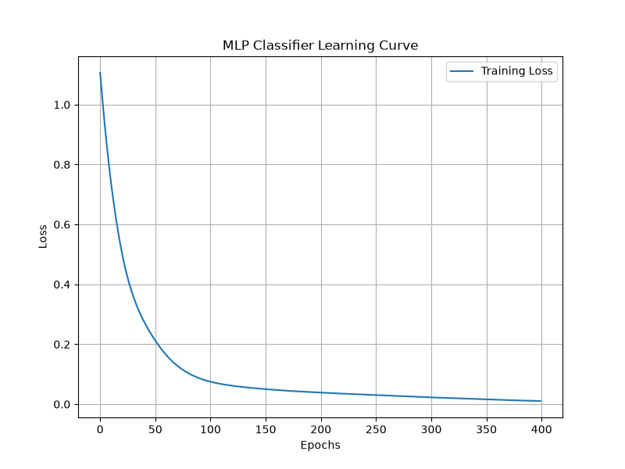
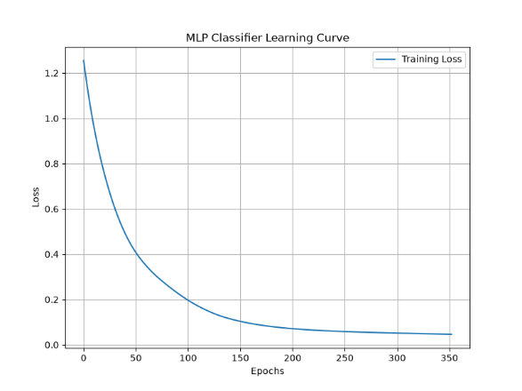
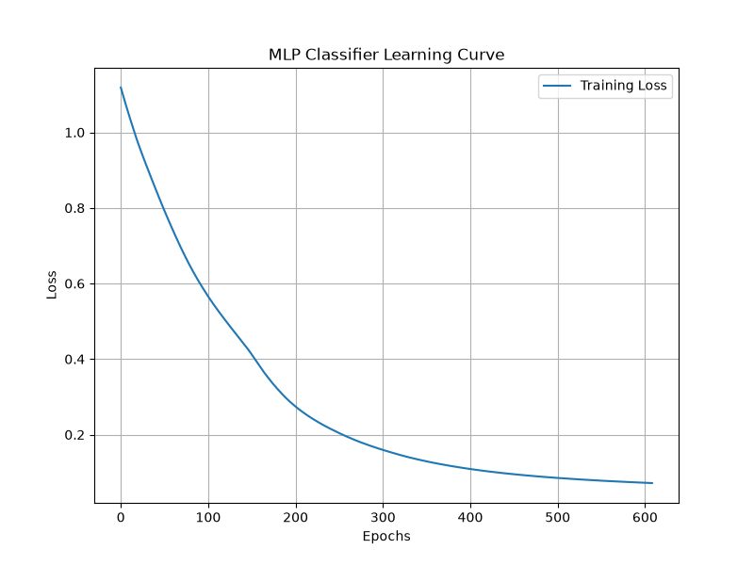
and the following are the results that shows by changing the number of layers and the number neurons how the loss is decreasing
2 Layers 10 Neurons
2 Layers 50 Neurons
2 Layers 100 Neurons

Q2: What configuration gives the best performance?
Ans: By changing the number of neurons and the number of layers are giving the best performance cause the loss decreasing rapidly.

- Task two:
Change the learning rate of the MLP model and observe its effect on convergence:
Q1: Train the model and plot the learning curve.
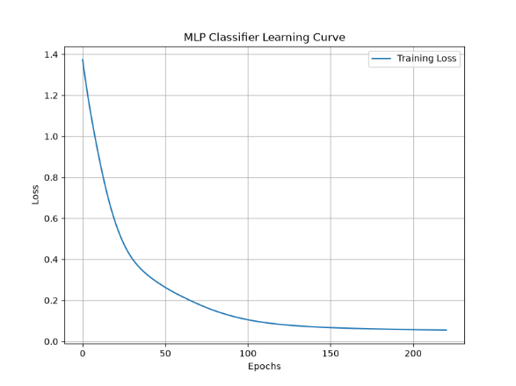
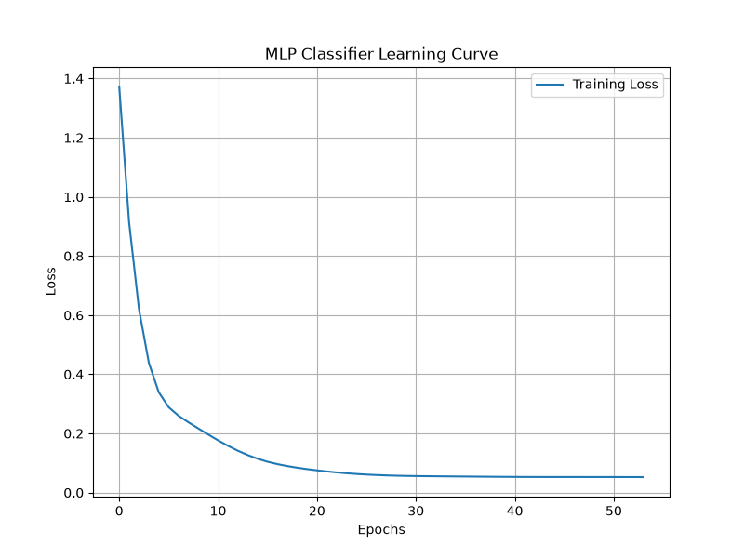
Ans: The following are the results of learning curve
1 Layer 10 Neurons LR 0.001
1 Layer 10 Neurons LR 0.01
1 Layer 10 Neurons LR 0.1

Q1: How does changing the learning rate affect the loss curve and the number of epochs?
Ans: The lower learning rate like 0.001 is required the more epochs to decrease the loss while by choosing the high learning rate 0.1 require a smaller number of epochs and the learning curve converging rapidly.
Q1: What learning rate provides the best balance between convergence speed and model performance?
Ans: The learning rate 0.1 provides the best balance between convergence speed and the model performance.

